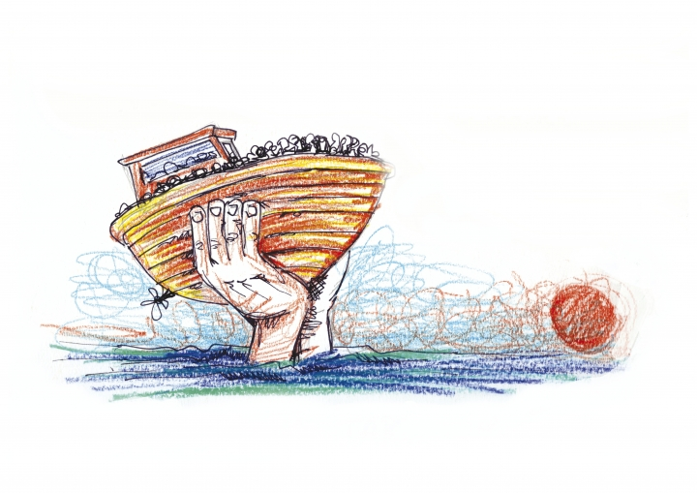

‘I was a stranger and you welcomed me...’
(Matthew 25:35)
‘Whoever welcomes me, welcomes the one who sent me’ (Matthew 10:40)


This resource offers prompts for conversation and reflection on the theme of hospitality and sanctuary. Though people of different backgrounds and beliefs are involved in the work of hospitality and sanctuary, this is a resource produced for churches. The resource is produced for use in Britain and Ireland. However, this material can be used and applied by Churches in all parts of the world. Working with refugees will be enhanced by linking up with churches in different parts of the world. Churches of all denominations and countries are part of the body of Christ and globally connected. We have immense connections to work together to build a better world.
In this third edition I have reorganised and re-presented some material, with some changes and additional writing. Facts soon go out of date, and it is important to check the latest figures by going to appropriate websites.
There is no attempt here to provide information on or to discuss immigration and asylum policy, or to make any political statement. I do write however as a person who has had a keen and critical interest on these matters from the age of 11 onwards. My interest has grown out of my own experience of immigration. What follows is a call to prophetic Christian witness and expression of hospitality as a clear challenge to hostility.
My own parents left their home in Panjab, India, as young teenagers soon after independence, and the partition, in 1947, a situation that led to one of the biggest movements of people across borders in human history. It was a movement that sadly witnessed much violence and bloodshed. Though they never spoke about it, I have no doubt they will have witnessed atrocity and will have been traumatised by it. Their parents will have suggested to them to go elsewhere for safety. They went to Kenya.
I was born in Nairobi where I lived till the age of 11 in 1964. Then, Kenya achieved independence, and with my parents and family I left for Britain, via a nine-month sojourn in what was then Tanganyika. By the time they were thirty, my parents had left their home twice as a result of political decisions of nations. My first home in this country was in Dudley, West Midlands.
From my earliest days of life in the UK people of Asian backgrounds talked with me, because I was fluent in English, about their immigration concerns and paper work.
So personally, rather than professionally, I have become familiar with immigration matters, policies and procedures. I am familiar with the fears, frustrations, and pains of people of all backgrounds around the decisions to leave home. I have determined to take simple steps to seek justice, mercy and humility in policy and procedure.
As a Methodist Minister, and Pastor, I have worked with others, especially in churches, to critique and challenge policy and procedure where it has been unjust and discriminatory. I have supported many campaigns to challenge unjust deportations orders. In the 1980s I supported people taking sanctuary in churches. I chaired the Sanctuary Working Group of the British Council of Churches, and helped to produce guidelines to assist churches giving sanctuary to people facing injustice.
In March 1997 I walked from Sheffield where I live, to 10 Downing Street, with a letter to the Prime Minister asking that Asylum Seekers, who are not criminals, are not detained in conventional prisons alongside convicted criminals, and for a fairer deal for Asylum Seekers. I also walked from the Home Office in Oxford to Campsfield Detention Centre in Oxford for the same reason.
As President of the Methodist Conference in Britain (2000-2001) I visited all the Detention Centres in Britain and Northern Ireland, following which I wrote a reflection entitled “Unlocking the Doors” (2001). I sent a copy to the Home Secretary.
In October 2005 I called a meeting, with Craig Barnett, a Quaker colleague, to launch the City of Sanctuary initiative. In 2007 Sheffield was declared UKs first City of Sanctuary. When others asked how they could follow this idea, to assist, Craig and I produced a short book entitled “Building a City of Sanctuary” (2010) with inspiring practical ideas.
At the time of writing, there are now over 100 cities/towns/areas in Britain and Ireland working with the City of Sanctuary vision, to build cultures of welcome and hospitality, cities we can be proud to live in. The idea is also being used for example in schools, universities, hospitals, gardens and places of worship. The City of Sanctuary website provides more details, and ideas for action.
This resource is supported by the Churches Together in Britain and Ireland (CTBI), and invites you to worship and pray, and reflect theologically around the themes of hospitality and sanctuary. It is biblically based, but invites you to engage in dialogue with people of other faiths and beliefs. People of all faiths, and those who profess no particular religious faith, share values of hospitality and sanctuary. This resource provokes the question what is it we need to do if we want a different, better world. I would be delighted if it prompts further and deeper reflection, prayer and action.
In the contemporary society around us, there is considerable hostility towards “the stranger”. We can all take action to shift attitudes and move people from these attitudes of hatred and hostility of people seeking sanctuary among us towards attitudes of welcome and hospitality.
Building the City of Sanctuary movement is a prophetic act. It is one way of changing the direction of the wind and influencing government policy.
There is recognition in this resource that all people want to be safe from harm, and that no one is really safe until we are all safe.
I will welcome positive feedback on how to build and strengthen this resource.
I have struggled to find Hymns on the rich theme of sanctuary. The only Hymn I know of that actually refers to “cities of sanctuary” is the one entitled “Beauty for Brokenness” (Graham Kendrick). The hymn “there are no strangers to God’s love” (Andrew Pratt) refers to “people seeking sanctuary”. Perhaps hymn writers and other users of this resource could write some more!
What follows places the material in the context of issues around the movement of people, especially refugees, though the concept of sanctuary can be applied to many different issues related to being safe from harm. The use of terms like migration, refugees, and asylum seekers require care and clarity. And remember, migration is a daily magisterial phenomenon all around us. For example, water, dust, ice, meteors, light, plankton, birds, meteors, as well as people, migrate every day in different ways.
Section One explores the idea of God taking sanctuary among us. Section Two calls for hospitality to the “stranger”, and considers biblical and some interfaith perspectives. Section Three introduces discussion around the themes of gift and redemption. Section Four introduces the idea of City of Sanctuary and building cultures of welcome and hospitality. There is a brief invitation to look at what it means to be a sanctuary to yourself and to others, and there are ideas for action, worship and prayer. The Act of Worship can be used to conclude this study. It could also be used as a resource for a Sanctuary Sunday (the Sunday in Refugee Week), or for the established Racial Justice Sunday which is observed on the second Sunday in February. Each section includes ideas for group work and personal reflection.
Make your place of worship a sanctuary where all are treated with warm welcome, generous hospitality and protection from harm. A Christian symbol of this is Holy Communion, a revelation of the world as it is meant to be, a foretaste of the heavenly banquet, where all are welcome and valued equally, and where no one is excluded or made to feel like an outsider.

All the strength of God to you.
Inderjit Bhogal
May 2019

- Bible Study and House Groups can use the four sections of this resource in the four weeks of Lent or Advent, or the four weeks leading up to Refugee Week, or another appropriate time. There are suggested group discussions and activities, and worship material. As a guide, allow ninety minutes per section. Each discussion activity suggested will require between fifteen and thirty minutes. Select discussion activities according to the time available to your group. Keep your small groups at five/six people per group

- The Order of Service provided can be used at an Act of Worship [midweek or on a Sunday, e.g. Sanctuary Sunday or Racial Justice Sunday]

- Use the themes of the resource for conversation and dialogue with people of different faiths and beliefs

- Use the resource for personal study and reflection

- The books, journals and articles listed will help individuals and groups to further their study and reflection

- Individually and/or as a group follow up some of the action points

- This resource can be used as a basis for developing your Church/Meeting a Church/Meeting of Sanctuary. See guidelines at the end of the resource.




Each year up to 1 billion people cross a border. Every two seconds, a person is forced to flee for safety. Every day 44,000 more people are driven from their homes.
The next twenty/thirty years will see huge movements of people as a result of environmental degradation, climate change, famine, war and persecution. It is a sign of our times, it alerts us that something is not right, and requires our most serious attention. Why are people moving? What are the stories of people who leave their countries and cross borders to go somewhere else?
According to the United Nations High Commissioner for Refugees’ (UNHCR) website there were 37.5 million refugees in 2005 and 68.5 million refugees in 2017, a new all-time high, and an unprecedented global situation (at the time of writing). Refugees cross borders for safety.

A refugee is defined by the Refugee Convention 1951 (UNHCR online) as a person who:

“owing to a well-founded fear of being persecuted for reasons
of race, religion, nationality, membership of a particular social
group, or political opinion, is outside the country of his/her
nationality, and is unable to or, owing to such fear, is
unwilling to avail him/herself of the protection of that country...”

An Asylum Seeker is someone who has left their home country and is seeking sanctuary in another country. It is not illegal or a crime to make such an application.

The UNHCR Global Trends 2017 Report on Forced Displacements records that wars, conflicts and persecution have forced more people than at any other time since records began to flee their homes and seek refuge and safety elsewhere. Wars make refugees. 90% of the world’s refugees were from countries close to conflict. Children constituted 51% of the world’s refugees, and there were 98,400 asylum requests from children who were unaccompanied or separated from their families. The UNHCR 2017 Report notes that this is made up of 40 million people displaced internally within their own countries, 25.4 million refugees and 3.1 million asylum seekers in industrialised countries. This means that 1 in every 110 people globally is an asylum seeker, internally displaced or a refugee. Syria (5.9 million), Afghanistan (2.7 million) and Somalia (1.1 million) produced nearly half of the world’s refugees in 2015. Turkey, with 3.5 million, Pakistan with 1.4 million, Uganda with 1.4 million, Lebanon with 1 million, and Iran with 1 million refugees were the top hosting countries in 2017.

The UNHCR Report 2017 notes that ninety percent of the world’s refugees are from countries close to conflict. Two thirds of the world’s refugees are from just five countries, namely, Syria, Afghanistan, South Sudan, Myanmar and Somalia. They are fleeing war. People flee for safety and security because they are scared, and live through horrors, humiliation and torture.

It is therefore argued (Betts and Collier, 2017) that the very concept of who a refugee is needs to be redefined. The Refugee Convention 1951 which confines a refugee to a person who is fleeing “persecution”, needs updating. Refugees include people fleeing persecution, but also the disorder, danger and insecurity of war and terrorism. Refugees are people looking for safety from danger to their lives, sanctuary while they can also earn a living, until they can safely return home. This was the original role of the UNHCR, to provide protection for refugees and to find long-term solutions to their plight. However, the definition of a refugee by the UN Refugee Convention 1951 is no longer adequate because it does not state who is a refugee today, it does not say who should provide safety, and it does not offer a long-term strategy (Betts and Collier, 2017).

Most refugees are displaced inside their own countries, or cross the border and go into the neighbouring country. There are refugees, of course, who take longer and more difficult journeys, risking life and costing huge amounts of money. We know stories of people holding the undersides of planes to make their journey; many travelling on crowded creaking old boats; others travel in air tight containers on trucks. Many thousands perish on the way and are lost in desert sands or the desolate sea.
People fleeing danger remain vulnerable and in need for safety and protection. Many lose their lives as they search for safety. A newspaper photo of Alan Kurdi, a Syrian boy refugee, whose deceased body was found on a beach became a symbol of this situation.

People will continue to travel from many countries and contexts, overcoming obstacles like walls, frontiers, borders, mountains and waters in search of safety and wellbeing.
Long term, this will only stop when nations stop wars, stop making weapons and instead invest in, and ensure everyone has access to equality, inclusion, education, homes, and hospitals, and build peace. Everyone wants to live in safety.
There are those, particularly women and children, who get trapped in the scandalous Human Trafficking trade. They get here and then disappear, or are enslaved, in the sex trade.
With the EU closing doors, there are no safe or legal routes for refugees and they are forced into the hands of unscrupulous smugglers and traffickers who charge them enormous sums of money for travel by unsafe and unreliable means. They could travel for a lot less by air if permitted.
Three hundred people drowned in October 2013 off Lampedusa, Italy. Nearly 3,000 people drowned or went missing in the waters between North Africa and Italy in 2014. Such deaths are a colossal humanitarian catastrophe. The “Mare Nostrum” boat rescue saved over 400 people a day following its introduction after the Lampedusa tragedy. Around 1200 people drowned in the Mediterranean Sea in one week in April 2015. It is the duty of governments to help refugees in need of shelter and sanctuary.
On the day it was announced that the Mare Nostrum was to be withdrawn, with support from Britain, Sir Nicholas Winton was awarded the Order of the White Lion in Prague (28/10/14) for organising the rescue of 669 mostly Jewish refugee children from Nazi-occupied Czechoslovakia on the eve of WWII. He organised rescue trains.
Every day myriads of people set out to cross whatever barrier is in the way to find safety and a better life. When people are deprived of their homes, their families, and familiar surroundings, they will be grateful for welcome, hospitality and safety. Migration has consistently been the hot potato of politics. At the time of writing the national debate has centred on the Windrush scandal which has exposed high levels of discrimination and harassment of people from the Caribbean who were invited [1948] to live and work in Britain. The debate has illustrated a hostile and prejudicial environment in which powerless “migrants” have to navigate citizenship in Britain, sometimes up to 70 years and more after arrival here. Upon taking her role as Home Secretary in 2012, Theresa May spoke of the aim in the Home Office to create in Britain a “hostile environment” for people without relevant documents. A hostile environment is a crucible of hostility. It is inhuman and inhospitable. The best response at the local level is to work hard to build cultures of welcome and hospitality. We can all be agents of change, and work with others to make life better. It is hard work that requires tough resolve and steely resilience. This work will help us to connect local stories with global stories.
Poet Laureate Andrew Motion’s words adorn the side of a Sheffield Hallam University building. The good sighted can read the words of the poem as they walk to the city from the railway station:
“O traveller from somewhere to here…to wander through the labyrinth of air,
Pause now, and let the sight of this sheer cliff become a priming place which
lifts you to speculate…
What if…?
What if…?
What if…?”
What if we could all work together to bring our diverse population into shared conversations, even if difficult conversations, on how we can work together to build better understandings, deeper relationships of mutual respect and trust, and come to genuinely accept each other as human beings?
My three challenges in response to the what ifs are:
- Be human, and always call others back to their humanity.
- Be hospitable, and always call others to express hospitality.
- Always challenge hostility. This is done by challenging inhumanity and inhospitality.
The way ahead is to widen and deepen relationships across different cultures, creeds, colours and identities, to end hatred, and together to build cultures where all are welcome, valued, belong equally together and have sanctuary and are safe. In words that come to us from the past, together we can seek the welfare of the city for in its welfare lies the welfare of all. We can be united in building hospitality. All people are human beings with names, stories and deep relationships. All want empathy more than sympathy, respect more than pity. We have fantastic opportunities in our multi-ethnic and plural societies to meet and eat with each other, to share our stories and discover our interconnectedness, and link the local with the global. We belong to each other. As the old Celtic proverb reminds us: it is in the shelter of each other that the people live.
We all want the best for ourselves. We can work together to ensure the best for all.
There is a challenge here to consider working to make your city, town, village, church, school, college, university, club or place of work, a sanctuary committed to building cultures of welcome and hospitality, especially for those in greatest need and danger. Primarily, this is a commitment to helping make the most vulnerable people safe from harm.
How we all relate to each other, and in particular to people seeking sanctuary and safety will be central to humanity. How we all treat those who are in greatest need for safety will be the measure by which we shall judge personal, national and international morality and spirituality.

“The stranger who resides with you shall be to you as a citizen among you; you shall love the stranger as yourself”
[Leviticus 19: 34]

The UN Refugee Convention was signed in 1951 in the context of millions of people made homeless by WW11, which ended in 1945.
It is a universal instrument, signed by 147 countries, that protects refugees around the world. It does not distinguish between “asylum seekers” and “refugees”.
Throughout history human beings have needed to seek safety.
By the end of WW11 there were 12 million displaced people.
The international community recognised the need to protect refugees.
The 1951 Convention applied only to Europe.
In 1967 it was extended to apply globally.

The Refugee Convention tells us:
● Who is a Refugee
● That Refugees should not be returned to face persecution
● That Refugees should be protected without discrimination
● That international co-operation is required through UNHCR to protect Refugees

The UN Refugee Convention drafted over 60 years ago is not a perfect instrument. It does not, for example, provide adequate protection for people:

● Fleeing war, conflict or danger or desperate poverty
● Fleeing en masse to escape genocide
● Women fleeing domestic violence
● Trafficked women, children men
● Seeking refuge following destruction of their homes due to climate change

No one should be forced to flee their homes. But when they do, people must be able to obtain safety and security. All countries should honour this commitment.
The Refugee Convention has saved millions of lives.
Is there a need for a new definition of who a refugee is?


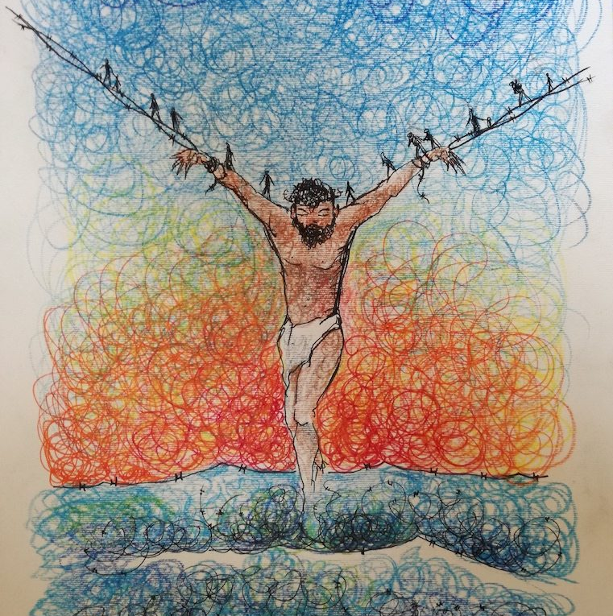

This section affirms that God is with us and takes sanctuary among us. God is not without witness anywhere in the world.
Bible passages to read for this section:
Exodus 25:8; Psalm 139: 8-10; John 1:14
The Bible places God at the centre of all creation (Genesis 1). The existence of God is taken for granted. The question that the Bible wrestles with, and illuminates is, how is God with us (Sobrino, 2004)? God is not confined to space. The entire created order is the sanctuary of God. Heaven and heavens heaven cannot confine God (1 Kings 8:27). Yet, God asks for sanctuary (Exodus 25:8).
God is revealed in the Bible as a companion, accompanying people in all their journeys, with all the challenges these bring, and present with them in all contexts (Psalm 139:8-10}. It is in their journeying that people encounter God, and particularly in the context of hospitality to “the stranger”. For example, in the story of Abraham and Sarah sharing a meal with three travelling strangers, they find they are entertaining angels (Genesis 18).
The Bible discloses God as a Migrant God (Song, 1982), and a God of a migrant, travelling, people.
- The first instruction of God is for people to “go and fill the earth”
- God instructs Abraham and Sarah to go out on a journey
- Joseph’s brothers go to Egypt because there was “corn in Egypt”
- God calls Moses to lead people out of bondage in Egypt and to embark on a new journey
- God chooses to dwell with the people, to take sanctuary among them. A simple Ark is built for the travelling, dynamic God (Exodus 25:8)
- Many of the key biblical texts are reflections of a travelling people
- Jeremiah instructs the exiled community to seek the welfare of the city where they find themselves “for in its welfare you will find your welfare” (Jeremiah 29:7)
This is the astonishing reflection in the Bible. God migrates.
This Migrant God takes another journey, a self-emptying journey, to be revealed in human form (Philippians 2:7), incarnate in Christ. This is the heart of the Good News declared in the Bible. God is revealed in Christ, as God who comes to us, dwells with us and is with us in the journey of life.
God is revealed in Christ.
The face of Christ is also seen in those considered to “the least important” (Matthew 25: 40).
In John 1:14 the Good News disclosed in Jesus is summarised:
“And the Word became flesh...and dwelt among us.”
The Greek word translated as “dwelt” comes from a root verb and its corresponding noun meaning “tent”, a word used also for the “Tabernacle” where the Ark of the Covenant was housed. It is a word used by Peter on the Mount of Transfiguration when he says “I will make three dwellings here” (Matthew 17:4 and see also, for example, Hebrews 8:5; 9:1, 21; 11:9.)
The “Tabernacle” was the portable sanctuary constructed at Sinai and primarily associated with the wanderings of the Hebrew people in the wilderness. It was the sacred space where God dwelt among people: “Make me a sanctuary, so that I may dwell among you” says God (Exodus 25:8).
The first one for whom human beings are required to provide sanctuary is God.
This sanctuary for God was not a house, not a mansion, not even a stable, or anything solid and permanent. It was mobile, and represented the mobility of the travelling God, accompanying a travelling people in all their journeying.


Get people into small groups.
The activity is to look at different references to ark, tent and dwelling in the Bible (e.g. Exodus 25: 8; Numbers 10:33-34; Matthew 17:1-5; John 1:14; Hebrews 8:5; 9:1,21: 11:9)
● What do we learn here about meaning of ark, tent, dwelling?
● What does it mean to give Sanctuary to God?
Read John 1:14
The word translated “dwell” is rooted in the noun translated as “tent” above. The sentence here literally means that God has pitched a tent among us, to live among us.

For personal reflection
Read John 2:13-22
● In what sense is our own body the Temple of God?
● What does it mean to say that God is our refuge/sanctuary, or to pray “be thou my soul’s shelter, be thou my strong tower” ?

Read Psalm 18:2; 27: 5; 46:1-3; 71:3; Deuteronomy 33: 27; Isaiah 25:4; Jeremiah 16:19
How do we take sanctuary and shelter in God? What does it mean to “abide” in Christ? (John 15)

The Nativity stories reveal God taking sanctuary among people with the vulnerability and dependency of a child.
The first requirement, for the birth of Christ, is a sanctuary, to make a little room (Song, 1982), challenging the idea that there was “no room” (Luke 2:7). See Appendix 1.
Not long after Jesus’ birth Mary and Joseph flee with him to Egypt as refugees for sanctuary (Matthew 2:13-15).

The stories surrounding Jesus and the early church, in Luke and Acts, continue the theme of journey, with a key story being the encounter with the risen Christ who meets and walks with his disciples as a “stranger” on the road to Emmaus, and how he was known “in the breaking of the bread” (Luke 24: 13-35). Jesus is often described as an unrecognised stranger (John 1:10-11; 6:20; 8:14,25; 21:12; Luke 24:13-35)
In this section we have reminded ourselves that in Hebrew and Christian spirituality, God migrates and is in our midst, takes sanctuary in us. We have opened discussion on human beings seeking sanctuary.



Read Matthew 2:13-15, and Reflect [for individual or group work]

● How would this family fare at a Port of entry into Britain today?
● What story would Mary and Joseph tell when asked on what ground they are seeking sanctuary in Britain?
● Would officials believe Mary and Joseph’s story about their child, and the dangers they face?

Invite individuals and groups to write a short story outlining the situation faced by the Holy Family fleeing to Egypt for sanctuary.

With stories like these at the heart of biblical witness some important questions are raised.
● What can be done to make room (Luke 2:7) for those who are seeking sanctuary among us here?
● How can you help people facing similar situations to be made welcome, have hospitality, be safe and have sanctuary in your community or nation today?



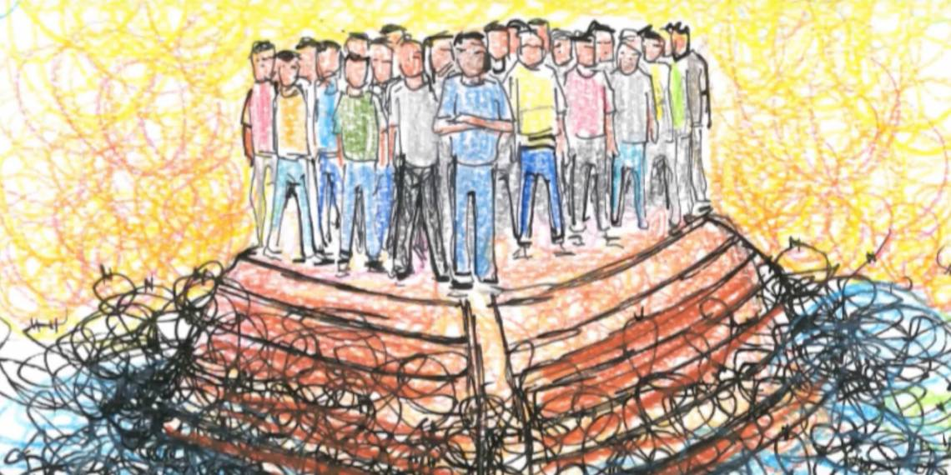

In this section we will discuss the practice and mutuality of hospitality, and the biblical understanding of “stranger”.
Bible passages to read for this section:
- Genesis 18: 1-8;
- Psalm 23;
- Isaiah 58:6-9;
- Luke 4: 18-19;
- Luke 10:25-37;
- Luke 14:15-23;
- John 2:1-10;
- John 6:1-13;
- Acts 2:43-46;
- Hebrews 13:2;
- 1 Peter 2:9-10


Brigit, the 5th Century Irish Saint was known for her hospitality. The words following are attributed to her:

I should like a great lake of finest ale, for the King of Kings;
I should like a table of the choicest food, for the family of heaven.
Let the table be made from the fruits of faith, and the food be forgiving love.
I should welcome the poor to my feast, for they are God’s children.
I should welcome the sick to my feast, for they are God’s joy.
Let the poor sit with Jesus at the highest place, and the sick dance with the angels.
God bless the poor, God bless the sick, and God bless our human race.
God bless our food, God bless our drink, all homes, O God, embrace.

Read Genesis 18:1-8, and Luke 24:13-35:
● Obtain or Google Rublev’s portrayal of the Holy Trinity for reflection.
● Reflect on the centrality of hospitality in daily life.
Hebrews 13:2 “Do not neglect to show hospitality to strangers, for by doing that some have entertained angels without knowing it”
● When has this been your experience?
● In pairs or small groups talk about the time when you were hospitable to a stranger, or when a stranger gave you hospitality, and were in the company of angels “without knowing it”.
● What did you learn in this experience?



A table is a symbol of hospitality in a world of migration.
We all look for tables, places, people and resources of rest and refreshment as we journey.
The Christian faith is rooted in the practice of hospitality with a table as a central image (Pohl, 1999). The table, and the food shared here is a foretaste of the Heavenly Banquet that God prepares for all people. God is the Host at the Heavenly Banquet where all are welcome, all have a seat, no one is excluded, and each guest is personally served, and treated equally with respect and dignity. At this table no one is ignored, or passed by without acknowledgement, no one has to reach out or beg to be noticed. All receive equally. No one merits or earns such inclusion. The realm of God is revealed as a feast where all are welcome.
We are called to practice such hospitality on earth, modeling the hospitality of heaven.
Hospitality is the key to interpret this.
Hospitality is also a good point for entry into dialogue with people of different faiths and beliefs, for hospitality is valued in all cultures. Hospitality reveals the heart of God. Hospitality transcends borders and cultural divides.
Hospitality is the frame of reference for interpreting the ministry of Christ. Jesus said to his followers, “whenever you meet in my name have some food and remember me”.
Holy Communion at its best reveals the new world we are called to build. God’s people are called to reflect God’s grace and generosity, to adopt an attitude of hospitality and spread the table, and symbolise the feast of God. Hospitality is the basis for building human community. The very meaning of compassion is to share bread with others.
One story Jesus used to illustrate hospitality is known as the parable of the Good Samaritan. Here it is a complete stranger in a hostile environment who shows the hospitality that reflects true faith with Jesus’ instruction to “Go and do likewise” (Luke 10: 25-37). What it means to “love your neighbor as yourself” is best seen in the offering of hospitality.
Jesus insists in his teaching to serve those in the greatest need. He said that is where his followers will see him and serve him. Those in the greatest need are not simply people who are to be recipients of service. They are prophets and offer the amazing gift in that they reveal Christ, and so give a greater gift back. This service is not a one-way process of paternalistic giving which puts the giver in a position of power. This service is not a feel-good factor to satisfy the giver. This service is a mutual expression of love and solidarity, a service with a two-way process of giving and receiving.
“In as much as you did it to the least of these you did it to me”
(Matthew 25: 40).
The many meals Jesus shared express hospitality, especially alongside those considered to be the least important. His followers are called to give and receive hospitality. We are challenged to see the image of God and to serve Christ in those who are different to us.
We give leadership when we, individually and communally, reflect the spirit of Jesus in service and hospitality.
In the story of Jesus and the two disciples sharing conversation and food on the Road to Emmaus, Jesus is the stranger, the host and the guest. That is us too. We are all strangers, guests and hosts. In this story it is the stranger who offers hospitality and in whom Christ is revealed.
True hospitality is never a one-way process. It is mutual. We all give and receive. We all serve and are served. And all of us enriched in the process.

For reflection individually or with a group:
Make a list of all the meals Jesus shared with disciples and others, from all four gospels.
Here is a sample list for example from John:
Wedding Feast in Cana [John 2], Feeding 5000 [John 6], a meal with a family [John 12], the Last Supper [John 13], a Beach Breakfast [John 21].
Then make a list of:
- Any common factors
- The various locations
- The variety of people participating
- The various people who contributed food
- The hosting qualities Jesus showed and required
Then reflect:
- Are all these meals sacramental?
- What insight do you bring from these meals to your understanding of the Last Supper/the Lord’s Table/the Eucharist?
- What distinctive insights do you take from these meals to all your meals?
- What do they teach us about hospitality?

In our days of instructions to be wary of strangers it is important to be clear about what is meant in the biblical instruction to “welcome the stranger”.
It is helpful to read chapter 13, Welcome the Stranger, in Brueggeman, W. (1991) Interpretation and Obedience: From Faithful Reading to Faithful Living. Fortress Press, Minneapolis [pages 290-310]
Brueggemann offers the following reflections:
In a world of hostility there is a counter-cultural gospel summons to practice hospitality.
The ways communities are structured create insiders and outsiders, those who are like us and those who are different from us, the included and the excluded.
The insiders have life and space to be, and are human. The outsiders have no access to life or space to be, and can be seen as less than human.
Some biblical scholars connect the sociological term “habiru” with the biblical term “Hebrew”, and see it as an alternative rendering of Hebrew.
The term “Hebrew” has its root in the verb “abar” meaning “to cross over”. The Hebrew thus refers to the one who is dis-placed/uprooted and who crosses over boundaries in the search for survival and life.
Brueggemann concludes that the people who finally become the “people of God” in the Hebrew Scriptures are among those whom the empire, for example Egypt, declared “outsiders”, “a threat”, these are the “strangers”.
One of the clearest ways to distinguish between the insider and the outsider is to consider issues around eating and hospitality.
For example, in Genesis 43:32, referring to the story of Joseph, we read:
“They served him by himself, and them by themselves, and the Egyptians who ate with him by themselves, because the Egyptians could not eat with the Hebrews, for that is an abomination to the Egyptians”.
The biblical witness reflects that the “stranger” is the “outsider” who may defile the “insider” if they were to eat together. But the “stranger” crosses boundaries in the search for space, security and life. The Hebrew, the “stranger”, is seen to represent the travelling, pilgrim people of God.

For discussion (read Genesis 43:32):
● What does the observation here tell us about the ritual power of food, the simple act of eating, and table manners?
● Where is the unease in this observation?
● Does the word “abomination” introduce here the idea of purity laws around food?
● Is there ritually “clean” or “unclean” food?
Read Mark 7 and Acts 10: 1-16 for further reflection.
● Which of our practices, including how we create “our” community/congregation, create “insiders” and “outsiders”?
● Are there people you are uncomfortable eating with?
● What makes some people feel uncomfortable to sharing in Holy Communion?
What kind of hospitality helps to build a truly inclusive community/congregation?

Jesus cuts through boundaries and separation between who or what is considered to be clean or unclean. Perhaps Jesus’ most subversive activity, for which he was criticised, was to eat with those considered to be the outsiders or social outcasts of his day. He expressed his solidarity with the most marginalised people around him by sharing food with them, and eating with them. He connected with people by sharing food with them. Jesus never felt he was defiled by eating with those others excluded.
Jesus left an example for his followers. He kept an open table. As followers of Christ our lifestyle are to reflect hospitality and solidarity, not hostility and segregation. Sharing food and hospitality with the most marginalised and excluded people is an act of holiness. Hospitality does not defile you, it makes you whole.
The followers of Jesus have seen in him, a good role model, the Good Shepherd (John 10: 11-18). His ministry prioritised those who were considered to “the least important” (Matthew 25: 40), and excluded from belonging. He included those who were excluded by eating with them. He opened his ministry by announcing and pointing to a new community, the Kingdom of God, where the excluded are included (Luke 4: 18-27), and where all are provided hospitality of the highest order (John 2:1-11).
Communities continue to create outsiders, those who are displaced, the “strangers”.
Jesus said that his followers will see and meet him in those considered to “the least important:
“Come you that are blessed by my Father, inherit the Kingdom prepared for you from the foundations of the world; for I was hungry and you gave me food, I was thirsty and you gave me something to drink, I was a stranger and you welcomed me, I was naked and you gave me clothing, I was sick and you took care of me, I was in prison and you visited me” (Matthew 25: 34-36).
One of the best loved New Testament stories is of encountering the risen Christ in the stranger over a meal, and how he was “made known to them in the breaking of the bread” (Luke 24: 13-35). It is a holy act to break and share bread with others, and share hospitality.
This is beautiful Gospel wisdom. Christian discipleship is about being on the way, following Christ, and encountering Christ in relationship with the stranger. The followers of Jesus have no option but to welcome the stranger, and to share good hospitality, and to journey as pilgrims together.
The theme of hospitality can be further developed in dialogue with people of different faiths, and those who profess no particular religious faith.
Hospitality is a practice valued and understood in all cultures and faith traditions.
All major world faiths teach the practice of the so-called Golden Rule:
Treat others as you want them to treat you.
Below are short readings and reflections from different faiths (some of these were shared by adherents of these faiths at a City of Sanctuary meeting in Sheffield):
Bahai
“Be kind to strangers, help to make them feel at home” (Abdu’l Baha).
Talk with Bahais about this.

Buddhist
“Oh Blessed One, may I not come to the complete awakening, if when I have done so, there should, in my Pure Land, be any discrimination of regard or privilege between humans and devas or between different individuals on such grounds as colour, relative beauty or other criteria, save the harmless kind of discrimination that is necessary for naming and keeping count of things”
(Dharmakara’s fourth vow, from the Larger Pureland Sutra).
Talk with Buddhists about this.

Christian
“In as much as you did it to the least important you did it to me”
(Jesus Christ, Matthew 25: 40).
Each Church displays the sign of the Cross, a reminder that here central place is given to the news that God is disclosed in one who is rejected or excluded.
Talk about this with Christians of different denominations about this.

Hinduism
God resides in all human beings. To welcome a guest therefore is to also welcome God. All guests are to be welcomed with the same respect that you would offer God.
Talk with Hindus about this.

Islam
“Do good to parents, kinsfolk, orphans, those in need, neighbours who are near, neighbours who are strangers, the companion by your side, the wayfarer you meet”
(Quran Surah 4 verse 36)
Talk with Muslims about this.

Jewish
“You shall also love the stranger”
(Deuteronomy 10: 19).
No other command is repeated more than this one.
Talk with Jews about this.

Sikhism
Every Sikh Gurdwara (temple) displays the Nishan Sahib, a visible sign signifying a place of worship and refuge where all are welcome for worship and offered welcome and hospitality without discrimination. Each Gurdwara practices the Langar, an open kitchen and meal.
Talk with Sikhs about this.

● Read Matthew 25:31-46
● Read the story from the Sikh faith below
These two readings provide material for fruitful dialogue between Christians and Sikhs.
The story is told that at a time of Sikh-Muslim conflict, Bhai Gunnaya Ji, a disciple of Guru Gobind Singh Ji was on the battle field, serving water to all who needed it, Sikhs and Muslims.
Many Sikhs complained to Guru Gobind Singh Ji about this.
“Your disciple Gunnaya Ji is serving water to the enemies and reviving them,” they said.
The Guru summoned Bhai Gunnaya Ji and asked him, “Why are you giving water to the enemies?”
Bhai Gunnaya Ji replied, “I have not given water to any enemy. Apart from your image I see no one. When you ask me for water, I serve it.”
The Guru was so impressed with his disciple that he embraced him, patted him on the back, and said, “You are blessed, and blessed is your service. Here, take this ointment and bandage. As you serve water, also apply this balm and bandage on those who are injured.”
The Guru also gave him a Towel, and said, “With this Towel, also wipe the face of the wounded...You have honoured me with your Roopa Seva (Image Service).

In this section we have reminded ourselves that hospitality reveals the heart of God, is the framework for the ministry of Christ, and therefore at the core of what it is to be Church. God calls us to spread the table of hospitality and build sanctuary for all.

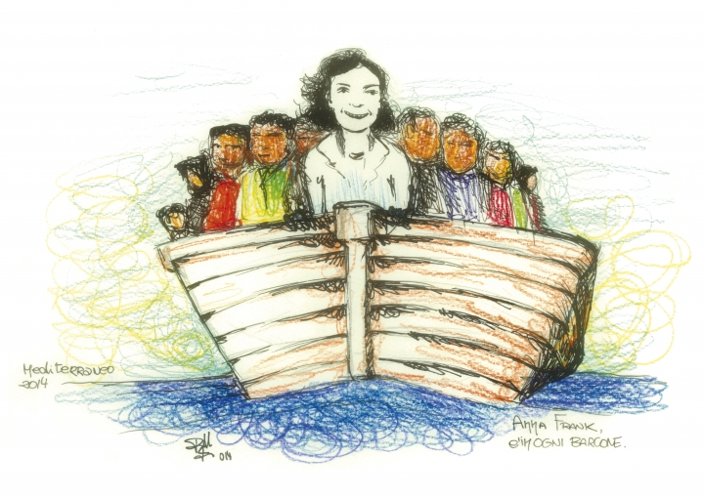

In this section we will explore the theme of the gifts and enrichment that come when the stranger is welcomed.
Bible passages to read for this section:
- Isaiah 53
- Luke 24:13-35


There is a promise in scripture that it is through those of a different language that God will speak (Isaiah 28; 9-11)
What is your experience of this?
● Contact a Refugee organisation to invite a speaker from another country to come and share their story with you/your group.
● What is God calling us to through the experiences and voices of those who speak a different language to us? What word of God do prophets of another language bring us?

The “stranger” joining a new community brings new insights, not least what it is to be excluded and hurt, into the public speech of communities. This includes:
- The wisdom of deep listening, hearing and responding (Exodus 2: 23-25; 3: 8 where we read of God who “heard” and “took notice” of the hurt of the Hebrews in Egypt, and came “to deliver them”).
- The experience and wisdom of embracing and including new comers with new status. The “stranger” can reveal the face of Christ (Matthew 25: 35-40). This can deepen the understanding of the words “once you were no people but now you are God’s people; once you received no mercy, but now you have received mercy” (1 Peter 2: 9-10).
Biblical witness insists that the formerly excluded people belong in community, not strangers but pilgrims together, with hopes and possibilities that transcend human barriers:
- They too dream of a new world, a new covenant (Jeremiah 31: 31-34), a new City for “here we have no abiding City, but we are looking for a City that is to come” (Hebrews 13:14).
- They too hold up the challenge to live by a new ethic. Most specifically “you shall also love the stranger, for you were strangers in the land of Egypt” (Deuteronomy 10: 19). No biblical commandment is more frequently repeated.
- There are prophets who preach this call to compassion and inclusiveness, and challenge of injustice (Isaiah 58:6-9; Micah 6:8).
- They too in their prayers make audible the cries and protests of the people (Psalms).
- They too reveal the face of Christ as we talk, listen, and share bread together (Luke 24:13-35).
In Ezekiel 34 there is a stinging criticism of the ruling authorities or shepherds who exploit people, and show no compassion. There is anticipation of a new order where God is the Good Shepherd:
“I myself will be the Shepherd…I will seek the lost, and I will bring back the strayed, and I will bind up the injured, and I will strengthen the weak, but the fat and the strong I will destroy, I will feed them with justice”.
(Ezekiel 34:15-16).


● Who is the “stranger” in your context? Remember we are all strangers to those who are new to us.
● How are you, your community and your nation blessed and enriched by the “stranger”?
● Find out about people who came to UK as refugees, and who made outstanding contributions here. There are many examples available on web pages, and from the Refugee Council.

Redemptive gift in the suffering of the stranger
All human beings desire dignity, respect and flourishing.
Most refugees and people seeking sanctuary come from situations of pain and suffering and danger. The experience of the rejection, suffering and crucifixion of Jesus Christ gives meaning to the experience of rejection and hurt. In the cost of Christ’s passion and pain is the gift of healing and hope. Here suffering is not willed by God, but is encompassed in God’s love. In the face of sorrow and hurt it is appropriate to ask why and to want to find meaning and wholeness in it. The Bible reflects the stories and experiences of a travelling people, undertaking difficult and dangerous journeys. Their hopes lie in a bruised Messiah.
In Isaiah 53 there is a humbling acknowledgement of the “suffering servant” who is:
- Afflicted and acquainted with suffering.
- Considered to be of no account.
- Taken away by a perversion of justice.
But it is the suffering and “stripes” and “bruises” of the suffering servant by which “we are healed”.
In the New Testament Jesus is seen to embody the suffering servant. From his childhood to his crucifixion, Jesus Christ was familiar with the experience of vulnerability, rejection, persecution and suffering. In many ways he was a stranger in his own community. His own disciples did not always understand or recognise him. He was arrested though he had committed no crime. There were those who “stood up and gave false testimony against him” [Mark 14:57]. He was held captive. He was tortured. He was crucified outside the city gates, the ultimate acknowledgement that human community is defined by who is “in” and who is an “outsider”. Jesus was betrayed, denied and abandoned by his best friends. This hurt him the most. He was nailed and crucified.
The earliest disciples and followers of Christ saw him as the “suffering servant” who bore the weight and agony of human sin as he hung on a cross.
The insight and truth proclaimed in this biblical testimony is that salvation and liberation come through suffering that is taken on and redeemed (Luke 24:26). The crucifixion of Christ declares that God is with people in the human agonies and tragedies, and gives them hope in their most awful experiences. The crucifixion of Christ declares the depth of God’s presence and love, a reminder that there is nothing worthwhile without cost. The resurrection declares that there is never a dead end, and insists on maintaining hope. There is the reality of hurt, and there is always the persistence of hope.
The Gospel does not go from crucifixion to crucifixion. It begins with the Good News that God is with us (incarnation); always desiring healing and the fulness of life (ministry of Christ); sharing our deepest hurts (crucifixion); and always holding out the possibilities of hope (resurrection).
We bear witness to this truth when we see, acknowledge, feel, take on, challenge, seek to eradicate and redeem suffering and injustice. We cannot live with the Gospel if we allow people to go from torture to torture, homelessness to homelessness, persecution to imprisonment, crucifixion to crucifixion.
We are called to practice the gospel by listening to, paying attention to, entering and identifying with the stories of pain and suffering that refugees and those seeking sanctuary, bear and tell. The weight of the sin of the world is exposed when self-interest makes anyone indifferent to the security of others.
In working with those who are hurting through the violence of war, famine, poverty and persecution, we together bear the weight of sin; we together struggle for justice, and seek the freedom of all. Thus, we share in God’s work of grace and redemption, and find hope and meaning in “the Lamb who takes away the sin of the world” (John 1:29).
Refugees and those seeking sanctuary among us are ambassadors, the messengers and witnesses of God. Cyrus the Persian, someone outside the covenant community, was an instrument of Gods liberation (Isaiah 44: 28-45:1). There is a promise in scripture, that it is through those of a different language that God shall speak (Isaiah 28: 9-11).
Challenge the framing and stereotyping of refugees and those seeking sanctuary as a cost, and a burden, as queue jumpers. Honour them for the gifts they are and bring, and advocate this change. It is the refugees that so often pay a very high cost, often losing all they have. Many lose their lives in their search for a better life.
In this section we have reminded ourselves that far from being a drain on our resources, those who come to live among us enrich us, they are messengers of God, and reveal to us the word of God and the weight of the sin of the world.


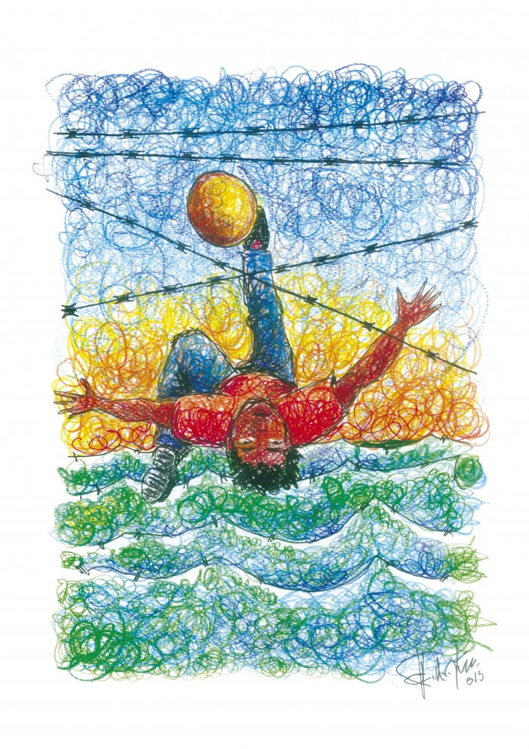

In this section the roots of the idea of City of Sanctuary, and the contemporary story of City of Sanctuary are discussed.
Bible passages to read for this section:
- Leviticus 19:34
- Numbers 35:6-15
- Deuteronomy 4:41-43
- Joshua 20:1-9
- Matthew 35:31-46

A simple exercise that can be used to introduce the theme of sanctuary for groups/congregations (two/three minutes)
Invite your congregation/group/audience to sit comfortably closer together.
Invite them to hold the hand of the person/s next to them, and to raise their hands as they are able to.
Ask them to describe the shape thus formed.
They may say: Arch, Roof, Crown etc.
The point to make is that the shape is like a roof or a simple shelter/house. It will also be like the nativity crib.
Sanctuary is about finding shelter in each other, and giving shelter to others.
As it says in a Celtic Irish Proverb:
Ar scath a cheile a mhaireas na daoine
[It is in the shelter of each other that the people live]

If your congregation/group/audience is uncomfortable about holding hands, try and show a copy of the logo of City of Sanctuary, available on the City of Sanctuary website.
You can explain that the logo celebrates human relationships, the value of companionship and the real sanctuary is the shelter and friendship people offer/give each other.
Alternatively/additionally, you can find and show a picture of the Sanctuary Knocker of Durham Cathedral, and briefly talk about it.

The idea of sanctuary and hospitality is valued in all faiths and cultures. The goal of building good community remains incomplete without the integration of all people, especially those whose lives are most in danger (including children, women, older people, victims of human trafficking, refugees and asylum seekers).
People are familiar with the idea of providing safety and sanctuary for suffering donkeys, birds, dogs, cats, seals and other creatures. This is good and worthwhile. But what about sanctuary for bruised human beings?
The Bible contains the command to “love your neighbour, as yourself”.
Yet this commandment, it has been pointed out (Sacks, 2002, 2015), is stated only once in Hebrew Scriptures (Leviticus 19:18). No less than 37 times the Hebrew Scriptures challenge people to “love the stranger”. There is no other command repeated so often.
A neighbour is someone who is a bit like yourself. A stranger is someone very different.
The Bible challenges us to love the stranger, to ensure they no longer feel like a stranger, but are pilgrims on a shared journey. Sacks (2002, 2015) reminds us that the Bible calls us to encounter God in the stranger, in those who are different.


The concept of sanctuary is thousands of years old and rooted in the Bible.
It is a development from Hebrew wisdom of “an eye for an eye and a tooth for a tooth”. This is the code that established the principle still used in the idea of “proportionality”, a principle used for example in the “Just War” theory. Do not use more force than is used against you. But there were, and are, people who will go beyond this principle, and for example, take life in revenge for smaller crimes. To prevent such harm Cities of Refuge were established.
According to the legislation set out in the Joshua 20:1-9, six Cities of Refuge were established (see also Numbers 35:9-15; Deuteronomy 4:41-43).
The idea of City of Sanctuary is a development of this ancient wisdom of the concept of Cities of Refuge (The Jewish Encyclopedia, 1901, online). Cities of Refuge were about giving protection to people whose lives were in danger. These Cities were to give refuge, or sanctuary to anyone, including a “foreigner”, who was accused of manslaughter, to prevent the automatic use of revenge as a rough, and unfair route to justice, while they waited for their case to be processed, and “until there is a trial before the congregation” (Joshua 20:6).
Cities of Refuge were about giving protection to people whose lives were in danger. The purpose of Cities of Refuge in the Hebrew tradition was the prevention of revenge, not the avoidance of law. The Rabbinic teaching is that roads leading to these Cities were to be kept in good repair, with clear finger posts, so that a refugee may be free to escape the hands of the avenger of blood and find safety.
City of Sanctuary is a contemporary expression of the City of Refuge idea. It progresses the idea to providing safety and hospitality to vulnerable people, for example - Asylum Seekers who are not criminals, children whose lives are in danger, victims of domestic abuse and older people who suffer indignity.


As early as the year 600, in the time of King Ethelbert’s rule, a general right to give sanctuary belonged to every church in England. Some cities were granted sanctuary status by Royal Charter. For sanctuary a person in difficulty needed only to get to the nearest church, and grab the Sanctuary Knocker, or sit on the Frith Stool. This was the way to avoid easy revenge and the sword.
Sanctuary was available in churches like Battle, Beverley, Colchester, Durham, Hexham, Norwich, Ripon, Southampton, Sprotborough, Stratford Upon Avon, Wells, Winchester, Westminster and York. They offered protection to debtors and criminals. Sanctuary was confined to the designated church, the limits being extended to the precincts, and in some cases to an even larger area.
For example, at Beverley, Hexham and Ripon, the boundaries of sanctuary covered the area within a radius of a mile from the church. The boundaries were marked by “sanctuary crosses”, some of which still remain. There is a sanctuary cross walk in Ripon.
In Beverley Minster, sanctuary was given for a month after which the person had to leave. They could return for another month if their life was still in danger, but had to leave after 30 days. If the person returned a third time, sanctuary was given permanently.
Durham Cathedral has a Sanctuary Knocker. Those seeking sanctuary held and rattled the Sanctuary Knocker to gain entrance. The Cathedral still has its Sanctuary Knocker on the door.
A Frith Stool is still seen in Sprotborough Church. The door on the parish church in Stratford Upon Avon has a Sanctuary Knocker.
By the time of the Reformation the concept of sanctuary was being discredited.
In the reign of Henry VIII the number of sanctuaries was reduced to seven. Criminal sanctuary was abolished by James 1 in 1623. Sanctuary for civil purposes was abolished by statute law in 1723. But the idea of sanctuary has survived.
The concept of sanctuary began to re-emerge in the 20th Century, first in El Salvador, as a form of protection from the activities of “death squads”. People were given sanctuary in churches. From there it was taken up in the USA when churches sheltered people from Guatemala and El Salvador who had been refused room and refuge.
There have been sanctuaries in churches in Germany, Switzerland, Denmark and Sweden as well as in Britain.
Sanctuary and hospitality are at the heart of ancient Irish and Celtic spirituality. In Nendrum, for example, on the shores of Strangford Lough are the ruins of a 5th Century Monastery established by St Caolan. Within the walls of the monastery there is clearly a space where sanctuary was provided for people who were fleeing violence, and whose lives were in danger. In Glendalough Monastery, County Wicklow, you can still see and touch the Sanctuary Cross. The Celtic term An Tearmann refers to an area around churches and monasteries that was to be free of political, religious and feudal conflict, and people would have sanctuary and be safe. Ireland still has villages called An Tearmann.
There is an old reflection of hospitality from the Island of Ireland in these words:
“We saw a stranger yesterday.
We put food in the eating place,
Drink in the drinking place,
Music in the listening place,
And with the sacred Name of the triune God,
He blessed us and our house,
Our cattle and our dear ones,
As the Lark says in her song,
Often, often, often goes the Christ,
In the stranger’s guise.”

An old Celtic proverb reads: ‘It is in the shelter of each other that the people live.’

In the 1980s a number of people took sanctuary in churches in Britain. For example, a Nigerian family took sanctuary in City Road Methodist Church, Smethwick (1988). Viraj Mendis, a Sri Lankan, took sanctuary in Church of the Ascension in Hulme, Manchester. A Nigerian family took sanctuary in the Downs Baptist Church, Hackney. A Chinese man took sanctuary in a Methodist Chapel in Marazion, near Penzance.

The ecumenical Community and Race Relations Unit (CRRU) of the British Council of Churches had a Sanctuary working group, and helped to prepare guidelines on sanctuary for churches. The successor of CRRU, the Churches Commission for Racial Justice (CCRJ) supported sanctuary in churches as a last resort. The Methodist Conference produced guidelines on sanctuary in churches.

City of Sanctuary is encouraging and working to build cultures of welcome and hospitality in all contexts, including communities and places of worship. There are guidelines for churches of sanctuary in this resource.

There are excellent initiatives being taken by churches and church groups building welcome, hospitality and sanctuary alongside refugees and those seeking sanctuary today. For examples, visit the faith section of the city of sanctuary website. See also the story of Restore (Appendix 2), and St Chad’s Sanctuary, Birmingham. St Nicholas, Bristol is a Church of Sanctuary. Derby Cathedral is a Cathedral of Sanctuary.



On 18th June 2007 Sheffield was declared by the Lord Mayor of Sheffield (Barnett and Bhogal, 2010) as the first UK City of Sanctuary. Founded in Sheffield in 2005, City of Sanctuary became a registered Charity organisation in 2006, and is now a growing movement. By June 2017 there were over 100 cities/towns/boroughs/areas in Britain and Ireland working with the City of Sanctuary vision, to ‘build cultures of welcome, hospitality and safety’. According to the City of Sanctuary website, this vision is spreading to other parts of Europe and beyond. Some supporters believe that City of Sanctuary is now part of ‘a movement within a wider movement’, networking with numerous faith-based and politically organised community organisations working with refugees.

The City of Sanctuary website further notes that it is ‘a mainstream, grassroots movement of local groups building coalitions of organisations from all sectors which make a public commitment to welcome and include refugees and people seeking sanctuary in their usual activities.’

The origins of City of Sanctuary are modest, and I personally did not envisage either that it would go beyond Sheffield or that it would experience a rapid growth. It emerged from an initiative I took. I have lived in Sheffield since 1987. From my earliest days in Sheffield, in my work as a Methodist Minister, I have been associated with key organisations working with refugees in the city, and their work. In conversation with others working in this context, it became clear to me that if the various organisations formed a network and worked together their contribution to supporting refugees would be even greater. In October 2005, with my colleague Craig Barnett, a meeting was convened which led to the launch of the City of Sanctuary initiative.

The meeting, held in Sheffield, was attended by around forty representatives of organisations working with refugees in the city. At the meeting, participants were invited to describe the work they were doing. Each organisation represented took a few minutes to describe their work. All the participants agreed that if the groups all collaborated and shared their wisdom, it would have a bigger impact on the city and work towards building a culture of welcome, hospitality and safety, especially for asylum seekers and refugees.

It was also agreed that if all the initial participant organisations were to sign a pledge of support, and get up to one hundred organisations in the city to become committed supporters, it would then be possible to ask the Local Authority to support this. If this could be achieved, there would be a strong case to be declared a City of Sanctuary, a city with a wide range of groups and organisations committed to working together to build cultures of welcome, hospitality and safety for refugees. The target was to achieve this by 2015. The idea was to encourage a new and collaborative approach to working with refugees, and to link local refugee organisations under a common purpose and image of sanctuary. The numbers of those pledging support grew quite rapidly.

In only two years however, in 2007, Sheffield was declared the UK’s first City of Sanctuary. Very quickly people in other cities began to ask how they could follow this idea. To assist, Craig Barnett and I produced a short book entitled Building a City of Sanctuary (2010) with inspiring practical ideas. This book gives some background information, and simple criteria for building a City of Sanctuary.

City of Sanctuary reflects the belief that the most effective change comes from a mobilised grass-roots movement. This is a politics in which the lead comes from people by acting collectively for social cohesion and change. It is located in an easily understood idea that lights up their passion leading to conversations that can grow to change cultures, and is accessible to all. It links local and global concerns across neighbourhoods and networks, and begins to go across geographies giving political meaning to space and place.
City of Sanctuary is a shared vision of places where many organisations and individuals work together to build cultures of welcome, hospitality and safety for all people, especially those whose lives are in danger, places they can be proud to live in. Places where:
- The skills and cultures of people seeking sanctuary are valued, and actively included in local communities and able to contribute positively to the life of the City.
- Youth and community groups, worship centres, local government, media, businesses, schools, colleges, universities and health centres have a shared commitment to offering sanctuary, so that it is seen as part of the identity of local people.
- People seeking sanctuary can easily build relationships with local people as neighbours, friends and colleagues.
By creating such a vision, and work, people can demonstrate the desire build a more just and humane approach to people seeking sanctuary among us.
To work towards City of Sanctuary is to build a shared vision, and provide a positive common goal and aspiration for a variety of organisations, groups and individuals. Many people are familiar with the “Fair Trade City” recognition granted when a number of organisations agree to buy, sell or serve Fair Trade goods. Similarly, City of Sanctuary embodies clear goals and is recognised when a significant number of local organisations sign up to the initiative, agree to provide welcome, hospitality and safety, and make a commitment to broaden support for the idea in order to gradually influence the culture of the city as a whole. To achieve recognition as a City of Sanctuary is only a marker on an ongoing journey. It is to arrive at a point where large numbers of organisations and individuals are committed to continue to work towards a shared vision of a city/town/place where all are welcome, valued, belong equally, have sanctuary and are safe.
City of Sanctuary builds on the history and spirituality of sanctuary. In the contemporary expression of Cities of Refuge, City of Sanctuary moves the idea towards a vision where local communities and organisations work together to challenge sectarianism, racism, hatred and bigotry and to build cultures of welcome, hospitality and safety for all residents. No one is safe until we are all safe. It recognises that the work of reconciliation and peace is not complete without the integration of all residents of the city. It builds a positive image of the city/town/village. The vision can be applied in many different contexts, such as schools and places of worship, and not just confined to cities.
City of Sanctuary is a contemporary expression of an ancient tradition. As in the past, it is about respectful manners, behaving well towards others with welcome and hospitality, and being safe to be with. Good manners precede law. It is only when manners fail that we have to create laws to provide protection. The original cities of refuge were set up to encourage good manners while people waited for the processes of law.
People from these Islands have benefitted from the hospitality of other nations and people when we have travelled abroad, and continue to do so.
‘Brexit’ has come to symbolise a focus across Britain, Ireland and Europe on immigration and the freedom of movement. This is an important conversation and requires open, honest, informed and respectful discussion. The City of Sanctuary idea is a contribution to this debate. It calls for hospitality as a way of challenging hatred and hostility.
There may not be refugees or people seeking sanctuary in your city/town/village/area. But news reports form opinion everywhere. It is important to be informed and to correct/challenge ill-informed, or prejudiced opinion everywhere.
There is a human, legal, moral and spiritual obligation on us all to provide safety and sanctuary to each other, and especially to those whose lives are in danger. This is important and urgent in our times of open hostility and hatred particularly towards people from other countries seeking security and sanctuary among us.

In what ways does your congregation work do to end hatred and hostility, and to build harmonious and hospitable communities where all are welcome, valued, belong equally, have sanctuary, and are safe?
Consider working to make your city, town, village, church, school, university, club, place of work a Sanctuary committed to building cultures of welcome and hospitality, especially for those in greatest need and danger.
See City of Sanctuary website for ideas.
See guidance provided in Barnett, C., Bhogal, I. 2010 [2nd Edition]. Building a City of Sanctuary: A Practical Handbook with Inspiring Examples. Plug and Tap, Ripon


All people can be vulnerable at some point in their lives, especially in communities that intentionally set out, like churches, to be welcoming to all, and inclusive. It is essential in churches to be pro-active in building safeguards and promoting cultures of safeguarding and environments of safety for all.
What churches can do includes:
- Taking steps to increase understanding within congregations about how they can build safer communities and spaces.
- Fostering deep cultural changes to fully understand what safeguarding means in every part of the life of congregations.
- Recognising that safeguarding is everyone’s responsibility.
- Developing robust measures to ensure that safeguarding policies are in place and are followed in all practice, including adhering to safer recruitment of church volunteers and paid workers.
- Providing structured systems of supervision and support for all those working with vulnerable people.
- Ensuring that any training undertaken is reflected in subsequent practice.
There is a need for commitment from senior leadership to safeguarding and safety to build sanctuary.
Churches that specifically work hard to welcome and offer hospitality to vulnerable and already hurt people such as refugees and those seeking sanctuary are required to be extra vigilant. Powerless people of all backgrounds are particularly vulnerable to harm and abuse. Provision of hospitality and safety is costly. Be a good host.

● What does it mean to provide a place of sanctuary, and to ensure that all among us are safe from harm?
● In what ways, despite our best intentions, may we inadvertently do harm, or allow harm to those who take sanctuary among us?
● How can we deepen awareness of the control, harm and abuse that people seeking sanctuary among us may have experienced in the past, and how may this affect their behaviour and ability to trust, and share their story?
● What safeguards and training do we need to make available?

We can be strangers to ourselves.
Welcome the stranger you are to yourself. Do not ‘oppress’ this stranger. This is the first step to welcoming the stranger.
Love your neighbour as yourself [Leviticus 19: 18].
Love the stranger as yourself [Leviticus 19:34].

● In what ways are you a stranger to yourself? Consider your own self as a stranger to yourself. Familiarity can be alienating.
● Imagine that you come to yourself as a stranger [Luke 15: 17]. The turning point in the prodigal is a coming to self.
● Where do you discern the hand of God or the face of Christ in this stranger you are to yourself?
● How would you welcome yourself?
● What hospitality and safety can you offer yourself?


Make space for yourself, and allow space to others.
Be a safe person to yourself, and safe for others to be with.
Be a sanctuary to yourself, model sanctuary in yourself. When you do this, you can better support others in being and building sanctuary. Allow others to give you sanctuary.
Pay attention to yourself and your body.
Your body is the Temple of God. It is sacred.
Below are some points for personal reflection and consideration. These were prepared by a member of the Belfast City of Sanctuary group.
A SANCTUARY TO YOURSELF | A SANCTUARY TO OTHERS
Allow yourself to BE  Accepting self as is – a work in progress | Allow others to BE  Accept others, help to develop independent relationships
Compassionate towards self | Compassionate towards others
Forgiving towards self | Forgiving towards others
Non-judgmental towards self | Non-judgmental towards others
Assumes self has done their best  Attaches no blame to self | Assumes others have done their best  Attaches no blame on others
Trusts in own capacity to recover, learn and grow | Trusts in others’ capacity to recover, learn and grow
Patient, unhurried, calm | Patient, unhurried, calm
Reflective – pays attention to and listens to self, and to your own body | Active – pays attention to and listens for others; support wellbeing and such listening in others
Puts self at centre of own life  [opposite of selflessness] | Encourages others to identify and pay attention to own needs
Promotes and is protective of own wellbeing | Respectful of difference
Recognises that no-one else is responsible for own happiness | Impartial – holds no agenda
Restorative – makes time for respite, however briefly, in own sanctuary | Restorative – invites others to take respite, however briefly, in own sanctuary
Motivated by wanting to – not by obligation, guilt or avoidance of guilt | Motivated by wanting to – not by obligation, guilt or avoidance of guilt

In this section we have reminded ourselves that sanctuary is not a modern or novel idea, but deeply rooted in our history and spirituality, and simple actions we can undertake to build sanctuary. There is a particular challenge to congregations to consider your church being a Church of Sanctuary. See appendix 3 for further reflections.

What you can do: positive action for groups and individuals
Consider working to make your city, town, village, church, school, university, club, place of work a Sanctuary committed to building cultures of welcome and hospitality, especially for those in greatest need and danger.
Do all you can to end hatred and hostility, and to build harmonious and hospitable communities where all are welcome, valued, belong equally, have sanctuary, and are safe.
Do what you can. Look at the website of City of Sanctuary for ideas and consider the following:
● Get involved in a City of Sanctuary group near you. Be a signed-up supporter. Get your church/group to be a signed-up supporter.
● Develop a welcoming, hospitable, inclusive environment in your church/group/place of worship/meeting.
● Commit yourself to initiatives which are there to end hatred and hostility, and to build cultures and communities in which all are welcome, valued, belong equally together, have hospitality and sanctuary and are safe.
● Remember and befriend homeless people, asylum seekers, refugees, the travelling communities, and all those seeking sanctuary among us.
● Invite people seeking sanctuary to your place of worship.
● Invite refugees/people seeking sanctuary to come and speak to your group/congregation.
● Never pass a Big Issue seller without acknowledging them even if you don’t buy a copy.
● Greet people with a smile.
● Remember those living in segregated communities who desire integration, community and safety, and support organisations working for integration.
● Open your homes to those ‘strangers’ who are seeking sanctuary...invite someone around for a meal...go out of your way to welcome and include them in your worshipping community.

● Work at making your worshipping community really inclusive, and at ease with diversity...you could also promote inclusive theology and biblical interpretation.
● Be vigilant and passionate about listening to those who feel most neglected, excluded and in danger, and do all in your power to build safe, inclusive, sanctuary spaces...in your own home, in residential and care homes, in congregations, clubs and local communities.
● Engage positively with Refugee Week and the Refugee Council.
● Mark Sanctuary Sunday annually at the end of Refugee Week.
● Volunteer to work with one of the many organisations working to welcome and support people seeking sanctuary.
● Read a book like Refugee Boy, or Two Caravans [details below].
● Learn to greet people of another country in their own language.
● List five prejudiced views you have heard about those seeking sanctuary in UK and find the actual facts on the website of the Refugee Council here: http://www.refugeecouncil.org.uk/policy_research/the_truth_about_asylum
● Be a safe person to be around in all company and contexts.
● Undertake the Sanctuary Way Walk in Ripon, if/as you are able [there are routes of 2, 3, 4 miles]. Google ‘Sanctuary Way walk, Ripon’ for details.
● In the work of sanctuary and hospitality you will find partners in all faiths and also in people who profess no religious faith but care deeply about safety for all – work with them.
● Support the work of CAFOD, Christian Aid, Tearfund, All We Can.
● Care for humanity goes hand in hand with care for the environment. Without clean air and water all living forms will stop breathing.
● And remember your body is a Temple of God and sacred. Care for yourself too. Scriptural wisdom is serious when it states ‘Love your neighbour as yourself; love the stranger as yourself’.



With ideas and suggestions for development of the themes of hospitality and sanctuary.

This can be used to conclude this study or on Sanctuary Sunday. See suggestions for Hymns at the end of this section.
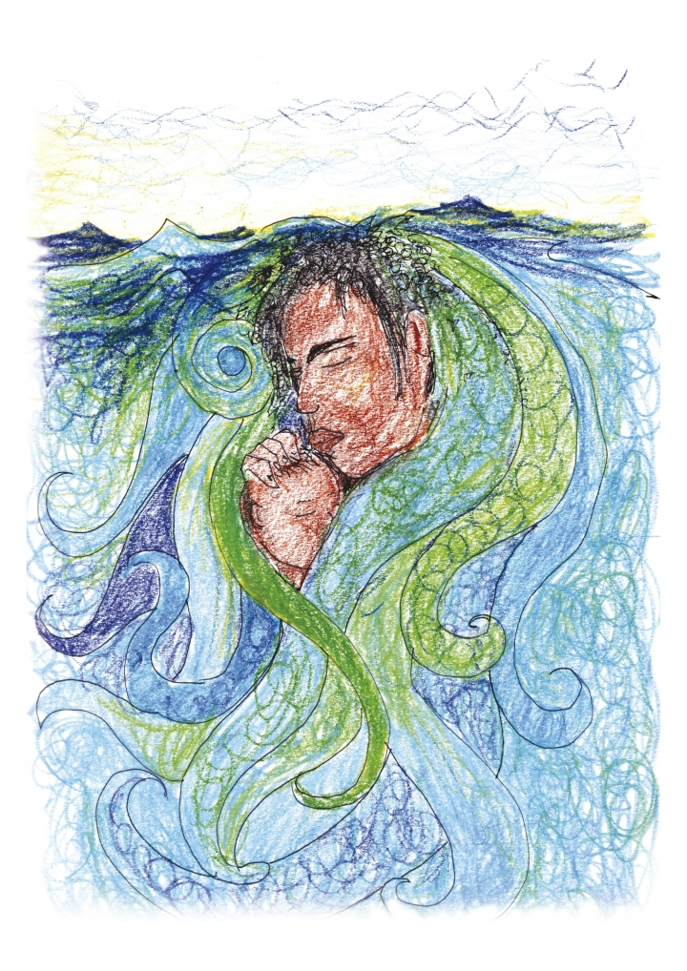





You may prepare your own, and here is a sample to consider:

Holy God, we bless you.
You are creator and make each one of us beautiful and blessed,
In your image and likeness.
You are with us.
You are our refuge.
You take sanctuary in us.
You call each one of us by name.
You know all our hopes and desires.
You know all our aches and pains.
You know the journeys we take.
Your presence surrounds us like a sanctuary.
Holy is your name.
Holy are your ways.

We bless you
For all you give in Jesus Christ.
In him you have shown the world new ways of living and loving.
We bless you
For you for all you give us in your Spirit,
New understandings of your word and wisdom,
Strength to live by each day.

Holy God, forgive us
For all the ways in which we and others assault and abuse your image in us, in others, and in all your creation around us.

Forgive us
That our living and loving
So often betrays the living and loving in Jesus that we profess.
Forgive us
For our failure to offer welcome and hospitality to the stranger.

Forgive us for turning away from your wisdom,
And for imagining we can live in our own strength.

As we worship, say our prayers;
Read from scriptures and meditate on them;
As we sing our songs;
And renew our commitments to you again,
And resolve to live by the principle of welcome and hospitality;
Grant us the assurance again
That you forgive us.

Heal us and strengthen us
That we may worship you well,
And go from here to live, love and serve
To your praise and glory.

Hallowed be your name in our worship and witness.
Hallowed be your name in all you call us to be, to do, and to say.

In the Name of Christ. Amen.


Flag up the theme and use a suitable activity as already suggested in this resource.
A simple exercise that can be used to introduce the theme of sanctuary
[two/three minutes]
Invite your congregation/group/audience to sit comfortably closer together.
Invite them to hold the hand of the person/s next to them, and to raise their hands as they are able to.
Ask them to describe the shape thus formed.
They may say: Arch, Roof, Crown etc.
The point to make is that the shape is like a roof or a simple shelter/house. It will also be like the nativity crib.
Explain that sanctuary is about finding shelter in each other, and giving shelter to others.
As it says in a Celtic Proverb:
Ar scath a cheile a mhaireas na daoine
[It is in the shelter of each other that the people live]
If your congregation/group/audience is uncomfortable about holding hands, try and show a copy of the logo of City of Sanctuary. It is available on the City of Sanctuary website.
You can explain that the logo celebrates human relationships, the value of companionship and the real sanctuary is the shelter and friendship people offer/give each other.
Alternatively/additionally, you can show a picture of the Sanctuary Knocker of Durham Cathedral, and briefly talk about it.


Select from those suggested above, or other appropriate ones

Use material provided in this resource, and illustrative stories from your experience or from the City of Sanctuary website.

Possible outline
● Open with a positive story of welcome and hospitality.
● Talk about the reality of hatred and hostility, and division in attitudes and communities.
● Use biblical material to highlight what it is to be a stranger.
● Use biblical material to highlight experiences of encountering God and Christ in the stranger.
● Use biblical material to hold up Jesus’ style of keeping an open, welcoming table.
● Conclude with the challenge to practice welcome the stranger and practice hospitality.


Write your own, or see samples below:

Let us pray.
Let us pray to God for the Church of Christ throughout the world, and especially this congregation with its diversity, and our neighbours of all denominations that we shall be blessed by the grace of God, and that all will be given strength to bear witness to the grace of God in our mission and ministry, worship and prayer.
God hears our prayers.
The Kingdom of God is within us.
Let us pray to God for all nations and all leaders that God will illuminate within and before them the pathways made of justice, mercy and humility for all to walk, and to build peace.
God hears our prayers.
The Kingdom of God is within us.
Let us pray to God for all who need help and support today, especially those we carry in our hearts for they are in our prayers that the grace of God will be on them and bless them.
God hears our prayers.
The Kingdom of God is within us.
Let us pray to God for all who are far from home, prisoners, immigrants, exiles, refugees and all who seek sanctuary that God will be the shelter of their lives and souls, and help us to build communities of welcome, hospitality and sanctuary for all.
God hears our prayers.
The Kingdom of God is within us.
Let us pray to God for ourselves, that we may be sanctuary, that we may be given the grace to follow Christ, and practice his art of hospitality and welcome to the stranger.
God hears our prayers.
The Kingdom of God is within us.
Let us with thanks hold before God those who have died and whose memory is precious to us. Grant them peace. Give strength to all who are bereaved. Bless all who mourn the loss of their homes and livelihood. And grant to us wisdom and encouragement from the vision, witness and example of all the saints who have gone before us.
God hears our prayers.
The Kingdom of God is within us.
We offer our prayers in the Name of Christ, and sum them all up in the words of the Prayer Jesus taught:
Our Father...
At a service of Holy Communion/Eucharist/Mass, here is an alternative prayer which may be said as bread is broken, and can be used at this point as intercessory prayer:
Holy God
As we break and hold this bread
We hold and offer to you
- The brokenness of those who live and struggle with hunger and disease
- The brokenness of those who are excluded or rejected from community
- The brokenness of communities and neighbourhoods
- The brokenness in relationships between nations
- The brokenness in household and personal relationships
- The brokenness in relationships between different faiths
- The brokenness in relationships between different Christian denominations
- The brokenness within congregations
- The brokenness we carry within our own bodies
- The brokenness we know when death tears away our loved ones
As we hold and offer you this broken bread,
And as we eat it,
Help us to keep trusting you are there in the midst of all our brokenness,
Working to heal hurts, keep hope alive, and make all things new.
Strengthen us that we may give and commit ourselves to share in your work.
Make us people of resurrection.
Feed us now and evermore.
And feed the world so that none may be hungry
And all may know welcome and hospitality.
In the name of Christ.


The sentences below can be used as a sending out and closing affirmation:

LITANY OF JUSTICE
Reader: Jesus said, ‘I was hungry and you gave me food.’ Made in the Image of God,
All: We see the face of Christ in all.
Reader: Jesus said, ‘I was thirsty and you gave me something to drink.’ Made in the Image of God,
All: We see the face of Christ in all.
Reader: Jesus said, ‘I was a stranger and you welcomed me.’ Made in the Image of God,
All: We see the face of Christ in all.
Reader: Jesus said, ‘I was naked and you gave me clothing.’ Made in the Image of God,
All: We see the face of Christ in all.
Reader: Jesus said, ‘I was sick and you took care of me.’ Made in the Image of God,
All: We see the face of Christ in all.
Reader: Jesus said, ‘I was in prison and you visited me.’ Made in the Image of God,
All: We see the face of Christ in all.
Reader: Jesus said, ‘In as much as you did to one of those considered to the least important, you did it to me.’ Made in the Image of God,
All: We see the face of Christ in all. We go from here to see and serve Christ in all.
Amen.

Hymns to consider
- Amen Siakudumisa
- Be Thou my vision
- Beauty for brokenness
- Brother, Sister let me serve you
- Come all you people, come and praise your maker
- I the Lord of sea and sky
- If you believe and I believe, and we together pray
- Jesus Christ is waiting
- Laudate Dominum
- Longing for light, we wait in darkness
- Lord of all hopefulness
- Let us build a house where love can dwell
- On the journey to Emmaus
- Sent by the Lord am I
- The Church is like a Table
- There are no strangers to God’s love
- Travelling the road to freedom
- We’ve no abiding City here
- When Christ was lifted from the earth

Some suggested further reading and resources for reflection

Books
- Akpan, U. 2008. Say You’re One of Them. Hachette Book Group
- Are You Happy with That? By People Seeking Sanctuary. 2013. Hafan Books, Swansea
- Allen, T. 2019. A Hundred Thousand Welcomes. Hafan Books, Swansea
- Barnett, C., Bhogal, I. 2010 [2nd Edition]. Building A City Of Sanctuary: A Practical Handbook With Inspiring Examples. Plug and Tap, Ripon
- Betts, A. and Collier, P. 2017. Refuge: Transforming a Broken Refugee System. Penguin, London
- Bhogal, I. 2000. A Table For All. Penistone Publications, Penistone
- Bhogal, I. 2001. Unlocking the Doors. Penistone Publications, Penistone
- Brueggemann, W. 1991. Interpretation and Obedience: From Faithful Reading To faithful Living. Fortress Press, Minneapolis
- Byme, B. 2000. The Hospitality Of God: A Reading Of Luke’s Gospel. Liturgical Press, Minnesota
- Cleeve, C. 2008. The Other Hand. Sceptre, London
- Eggers, D. 2006. What is the What? McSweeney’s
- Harding, J. 2000. The Uninvited: Refugees at the Rich Man’s Gate. Profile Books, London
- Houston, F. 2015. You Shall Love the Stranger as Yourself: The Bible, Refugees and Asylum. Routledge, Oxford
- Jamison, C. 2007. Finding Sanctuary: Monastic Steps For Everyday Life. Phoenix, London
- Lewycka, M. 2008. Two Caravans. Penguin Books, London
- Newman, E. 2007. Untamed Hospitality: Welcoming God and Other Strangers. Brazos Press, Grand Rapids
- Olofinjana, I. and Finamore, S. (editors). 2017. Moving Stories: The Bible and Migration. Baptists Together, UK
- Pirouet, L. 2001. Whatever happened to Asylum in Britain? A Tale of Two Walls. Berghahn Books, Oxford
- Pohl, C. 1999. Making Room: Recovering Hospitality As A Christian Tradition. Eerdmans, Grand Rapids
- Price, D. 2018. Welcome to Sheffield: A Migration History. ALD Design and Print, Sheffield
- Reaves, J. R. 2016. Safeguarding the Stranger: An Abrahamic Theology and Ethic of Protective Hospitality. Pickwick, Eugene, OR
- Richard, L.2000. Living the Hospitality Of God. Paulist Press, New Jersey
- Sacks, J. 2002. The Dignity of Difference: How to avoid the clash of the civilizations. Continuum, London
- Sacks, J. 2015. Not in my Name: Confronting Religious Violence. Hooder & Stoughton, London
- Salgado, S. 2000. Migrations: Humanity In Transition. Amazonas Images, Paris
- Sanghera, J. 2007. Shame. Hodder & Stoughton, London
- Saperstein, D. (Ed). 1987. Providing Sanctuary: The Jewish Role. Commission on Social Action of Reform Judaism, Union of American Hebrew Congregations
- Sobrino, J. 2004. Where is God? Earthquake, Terrorism, Barbarity and Hope. Orbis, Maryknoll, New York
- Song, C. S. 1982. The Compassionate God. SCM, London
- Tennant, V. 2000. Sanctuary in a Cell: The detention of Asylum Seekers in Northern Ireland. Law Centre (Northern Ireland), Belfast
- Vanier, J. 2005. Befriending The Stranger. Darton, Longman and Todd, London
- Weller, P. 1987. Sanctuary: The beginnings of a movement? Runnymede Trust, London
- Zephaniah, B. 2001. Refugee Boy. Bloomsbury, London

Reports
- Religion, Society and The Other: Hostility, Hospitality and the Hope of Human Flourishing. Papers presented by the Elijah Interfaith Academy Think Tank in preparation for the meeting of world religious leaders. Sevilla, Spain [14-17 December 2003]
- Saving Sanctuary. The Independent Asylum Commission’s first report of conclusions and recommendations [2008]
- The State of Detention: Immigration Detention in the UK in 2014. Detention Action, London
- The Report of the Inquiry into the Use of Immigration Detention in the United Kingdom: A joint inquiry by the All Party Parliamentary Group on Refugees and the All Part Parliamentary Group on Migration. House of Commons [2015]

Journals
Bhogal, I. 2010. Sheffield As A City Of Sanctuary. Coracle. Spring 2010 [Issue 4/43], pages 1-3
Bhogal, I. 2012. Sanctuary For All. Magnet. Winter 2012 [Winter 2012 Number 99], pages 6-8
Darling, J., Barnett, C., Eldridge, S. 2010. City Of Sanctuary – A UK Initiative For Hospitality. Forced Migration Review. February 2010 [Issue 34], pages 46-47
Goff, C. 2010. City Of Sanctuary: Preparing A Warm Reception. New Start. May 2010. [Issue 478], pages 18-23

Movies
Babettes Feast [beautiful story of a refugee’s generosity]
Le Havre [the gift of giving sanctuary]
Moving to Mars [follows two refugee families moving from a camp in Thailand to the British City of Sheffield]

Music
Maryam Mursal, The Journey. Real World Records CDRW70 [1998].
Maryam is Somalian. She fled from Somalia at the height of the civil war with her five children. This album offers vibrant songs telling the story of Maryam’s flight. Tracks include Kufilaw [take care] and Qax [refugee] which she wrote on the way.
Online
Refugee Tales: A call to end indefinite immigration detention @ refugeetales.org
http://lithub.com/15-works-of-contemporary-literature-by-and-about-refugees


Make more room
[The reflection below was first published in the Methodist Recorder, December 2013]
Mariana was sitting, hunched, on an old milk crate that was stood up on its side. It was freezing cold. She wore a black woollen scarf over her head, a black coat, black trousers, and red socks and sandals. She had a child aged no more than one wrapped up warm in a dark green shawl in her lap. I had just arrived on the spot, a bus shelter. As I waited for a bus I sat beside Mariana. She had caught my attention, pleading with me to buy the magazine she was selling.
It has been my practice to always acknowledge and greet people like Mariana in the street, and never to ignore them, even if I have no intention of buying from them. So we talked for a while.
Mariana told me her name [I am not using her real name here], and that she was of Roma background. At one point I asked her what makes her tolerate the severe cold weather, and frosty attitudes from many who walk past with most ignoring her completely.
“Make room, make more room for my babies,” she repeated. By babies she meant her children, and she has four under the age of ten. She is doing what she can to make room and life better for her babies.
I did not ask Mariana what her age was, but she looked much older than her years. She could have been a Grandma.
On the bus I reflected on the many recent news items around prejudice and hatred towards people of Roma backgrounds in cities like Belfast, Boston and Sheffield, and European Union rule changes from 1.1.2014 when restrictions on working rights would end. There will not be a mass migration of Bulgarians and Romanians coming to Britain in the New Year.
The EU Immigration and Employment Commissioner, Laiszlo Andor, has asked Britain to be less “hysterical” about immigration. Bulgarians and Romanians are more likely to go to Italy or Spain. When EU migrants come to the UK they come here to work. They are more likely to be in work than on benefits.
In our ageing population, with deepening pension fund concerns, we need to welcome and embrace more migrant workers. It is too simplistic to blame our mounting economic debt and youth unemployment on immigration.
“Make more room” is the plea of Mariana and people all around the world prepared to put up with harsh realities and hostility in order to work for a better life. The voice of those who cry “there is no room” has to be challenged with attitudes and actions to “make more room”.
This is the beginning and challenge of the Gospel of Christ. The pregnant Mary and Joseph arrived in Bethlehem for registration according to the rules. Visualise a desperate family knocking on door after door asking for accommodation. Mary gave birth and sat with Joseph and her baby in a cattle shed because “there was no room for them in the Inn” [Luke 2:7]. A different Gospel meditation is that “he came to what was his own, and his own people did not accept him” [John 1:11]. But the Inn Keeper was at least willing to make room, even if just a little room with the cattle, for the desperate family.
The first requirement for the manifestation of God in Christ was to make room among people and within people. The mission of God begins with a plea for a little room. Jesus’ ministry reflects the mission of God. He called people to openness, to be unbound, to open closed doors and hearts, and he kept an open table for all.
The Gospel insight is that the mission of God is seen when more room is made for just one person, when one person is freed from loneliness, or homelessness, or malnutrition. Unprecedented global movements and trends in the economy, migration and the refugee crisis challenge the Churches to work ecumenically and internationally with all people to prioritise the call of God to make more room.
We can all share in this mission of God and conduct it in the Name of Christ. We can begin by taking simple steps to make more room in our hearts and minds, in our congregations, in our local communities for people like Mariana and her babies. By showing how to make more room, we can play our part in moving people away from hatred, hostility, exclusion and violence towards a new world where all are welcome, belong equally, have sanctuary and are safe.
Before I got off the bus, I recalled again Mariana’s face and demeanour. She reminded me of two important people in the Christmas story, namely Simeon and Anna [Luke 2:25-39]. The nativity focus is very much on a baby. We have the young refugee family of Mary, Joseph and Jesus. There are the visiting Kings from afar. Simeon and Anna place older people at the heart of Christmas too and accord them respect. They adored the baby. In our ageing population, make room for older people in your Christmas festivities.
Simeon is described as “righteous and devout”. I’m sure these words could apply to Anna too. Simeon held the Christ Child and prayed, “now lettest thou thy servant depart in peace” [Luke 2:29 King James Version].
Just as I write this the news has come through that Nelson Mandela has died. Mandela dreamed of “a society in which all South Africans, both black and white, will be able to walk tall, without any fear in their hearts, assured of their inalienable right to human dignity, a rainbow nation at peace with itself and the world”. He has played his part in calling us to God’s mission to make room for everyone. Like him, we can rise to this challenge and keep his dream alive too.


Welcoming the stranger: Life with Restore
[the words below are an extract from an article that first appeared in the Bible Society Journal, The Bible in Transmission, Spring 2015], by Shari Brown
Restore is a project of Birmingham Churches Together, whose mission is to welcome, include and assist integration of refugees and those seeking sanctuary from persecution. Restore's work is relational and rooted in responding to the needs of new arrivals who have experienced loss and trauma back home and are attempting to rebuild their lives in Birmingham. Our primary service is one-to-one befriending where volunteers stand alongside refugees or asylum seekers and offer support. One refugee wrote: "My befriender is very supportive, informative, caring and considerate. Restore has enabled me to confidently integrate myself into the community. I found Restore like a shelter for people like me who are lost in this world."
Restore was founded in 1999 by a group of churches in Birmingham, who wished to help Kosovans fleeing conflict and other asylum seekers arriving in the city as a result of the new policy of dispersal from the south east to different regions of the country. Restore was adopted by Birmingham Churches Together in 2000 and has been a strong expression of ecumenical mission work over the last few years. Whilst retaining a befriending focus, Restore has developed other aspects of work such as social activities, training to equip refugees for work, awareness-raising on refugee issues, and advocacy - both on behalf of clients and in seeking to influence asylum policy and practice. Restore is a project open to all, but it remains a faith-based project, deeply committed to the call to ‘welcome the stranger’. The following volunteers share what motivates their involvement in Restore’s work:
“My motivation has been based upon a desire to do something to counter the blatant injustice, prejudice and hypocrisy with which the machinery of government is used to persecute some of the most vulnerable people amongst us. That’s it … as Christians we are mandated to love our neighbour and to show solidarity with the oppressed and poor. Restore is the practical means for making a positive contribution.” (Philip Rogerson)
“Almost all my life in this country (50+ years) I've lived and worked amongst people arriving from other countries and cultures and having originally myself uprooted from a very homogenous culture (Sweden), it feels as though over the years this diversity has become part of my DNA. I myself have received so much through this experience with so many diverse encounters that it seemed very natural and obvious to get involved with Restore. I guess I also know a little about what it means to leave your own country, the pain and the loss, although I did so for very different reasons compared to refugees. The prevalent xenophobia in this and other countries is so against everything I believe about ‘welcoming the stranger’. My Christian faith is obviously a strong motivation." (Kerstin Eadie)
"My motivation for being a Restore befriender is the injunction as a Christian to reach out to the most vulnerable and marginalised of one’s society. I desire to live in a society that is inclusive and affirming, as even Christ’s love is ever inclusive and affirming. I am inspired by the knowledge that God in Christ shared the journey of being a refugee and thus in befriending refugees, we befriend those of similar journeys to Christ. The distinctively subjective reason for my engaging in Restore’s work is that I, too, had to seek asylum and am forever grateful that I was given the opportunity of moving from unfreedom to freedom in my adopted British society. Lastly, given the nature of a British society that is in flux, and not for the better, if I don’t do it, who will?!" (Brian Brown)
We do not deceive ourselves that befriending and social activities can transform situations, but remarkably people affirm the healing aspect of social interaction, recreation and the sense that somebody cares! One asylum seeker described the impact of men’s activities as follows: “For most asylum seekers, hardly a day passes without you getting bad news either coming from the Home Office or from events taking place back home. “Your house has been burnt down”. “Your family don’t have money to pay rent”. “Your wife has been taken by informers for interrogation”. The list goes on and on. All this boggles your mind making your life miserable. Then a phone call comes up asking if you are available for a Restore men’s event. This is good news to a lonely man who has not been out for a long time. We have been to so many places of interest in and around Birmingham, played pool, football, table tennis and gone swimming. This has helped keep us busy, reduce stress and lift self-esteem. Visiting and meeting different people makes me feel relaxed and confident about the future.”
It is not all depressing either. Restore has its experiences of great joy when refugee status is granted, family reunion takes place, and people's lives move on for the better. A befriender writes of his witnessing a 'truly holy moment':
“My befriendee phoned me very excitedly to say that finally his wife and two children have their visas to join him in the UK. He fled Darfur three years ago and hadn’t seen them since – in fact, for two years they had no contact and he didn’t know whether they were alive or dead. My wife and I drove him and his friend to Heathrow to meet them. The plane landed on time at 10pm, but we were still waiting in a rapidly emptying Arrivals area at 11pm. At last the aluminium doors open and there they were – she in a long black robe with red head-scarf with the children, in their best clothes, hesitant beside her. My befriendee does not move. His wife walks slowly, with great grace and dignity, to the end, and he is there facing her. It was like slow motion. They folded into a gentle embrace, almost as if they weren’t quite sure if the other was solid flesh and then simply stand and hold each other. She is wiping away tears as he stoops ever so gently to clasp his son and then his daughter. It is reverent – a truly holy moment. The evening was a time of great joy, for us as well as the family who now begin life together in a new country where they are safe at last.” (Charles Worth)
Paulette Mengnjo, a refugee, has the last word:
Paulette fled persecution in the Cameroon and sought sanctuary in the UK. She speaks with frustration about the lack of quality legal representation she received when first applying for asylum. Her case was refused by the Home Office and a Judge upheld the decision, determining that she was not a high-profile political activist and could relocate to a safe place in her home country. Destitution, and detention in Yarl's Wood Removal Centre followed. It was only after a much-respected legal firm took on her case, referred her to Freedom from Torture for a medico-legal report and submitted a fresh application that she was granted refugee status. Asked what kept her going through the tough years, she responds: "Hope kept me going." She then refers to the advocacy of agencies like Restore, the support of her church community at Olton Baptist, and individuals who generously provided accommodation, financial support and friendship.


Becoming a Sanctuary Church/Meeting/Place of Worship: Revitalizing an ancient tradition
Sanctuary, or hospitality-with-safety, is a long-standing prophetic theme of the Hebrew and Christian Scriptures, the foundation for which is found in the Law-books of the Hebrew Scriptures, and echoed in Jesus’ teaching about how we treat the neighbour and the outsider. The Hebrew Scriptures refer once to love of neighbor and 37 times to love of the outsider or stranger. Sanctuary in churches used to assist those who claimed to be innocent of a crime, but in the last few decades has operated in churches in Central America, the United States and the UK primarily to protect immigrants or refugees facing deportation by the state. Now we need Sanctuary Churches who wish to meet and greet new arrivals fleeing from war and hunger. We need sanctuary for all vulnerable people.
It is helpful for congregations to study resources like this one to build a biblical basis for discussion, and developing the idea of a Church of Sanctuary.
The City of Sanctuary works by three steps to being a School, Church, Quaker Meeting, University of Sanctuary.
The three steps are as follows. Involve the whole congregation.
Learn about what it means to be seeking sanctuary, and be actively involved in awareness raising
Embed – take positive action to make welcome and inclusion part of the values of your congregation or community, to support those seeking sanctuary and refuge, and to include them in your activities
Share – with pride, your vision and achievements: let others know about the positive contribution refugees make to society and the benefits of a welcoming culture for everyone
This resource provides reflection on approaching these steps. You will also find encouragement and resources in City of Sanctuary groups near you.
Involve people seeking sanctuary, and refugees, in helping you to progress and achieve these principles.
Talk about how you will sustain this work in meaningful ways.
Below are some suggestions to assist you, including a template from Birmingham. This is not a tick box exercise. It is a learning process for the whole congregation. Do not regard these suggestions as prescriptive. Each context is different. How congregations engage with these issues in rural contexts will be different from those in urban and city environments. Explore best ways forward in your context.
When you feel you are ready, you can apply for recognition as a Church/Place/Meeting of Sanctuary. Application forms are not complex or cumbersome, and are available from City of Sanctuary.
A group of churches in a parish/circuit becoming recognised churches of sanctuary can agree together to be known as a parish/circuit of sanctuary.

Here is a template prepared by me, and Barbara Forbes of Birmingham City of Sanctuary to provide some guidance. It can be used/adapted by a congregation.
Birmingham City of Sanctuary
Places of Worship of Sanctuary
If your place of worship would like to be recognised with a Church of Sanctuary certificate, please have a look at the points below to see if this is something you could pursue. All places of worship are different so this is not meant to be prescriptive, rather it is a tool for self-assessment. The common denominator is that the worshipping community commits to being a place of sanctuary and affirming the value of each individual human being.
 | What we are doing already | Steps for further development
Learn about what it means to be seeking sanctuary
Paid staff and volunteers
All staff and volunteers are aware of what it would mean to become a Place of Worship of Sanctuary.
All staff and volunteers are involved in the process.
Worshipping community
The community as a whole is aware of and welcomes this initiative.
Raising awareness
The staff, volunteers and community will become aware of
- Why people become refugees
- Where refugees come from;
- The differences between refugees and asylum seekers and other migrants;
- Why some refugees come to the UK and to your city;
- Why some refugees are destitute;
- Why refugees and asylum seekers need protection.

Identify “Sanctuary Champions” who will work together to help the place of worship to learn about sanctuary and seeking sanctuary, and help to raise awareness.
The “Sanctuary Champions” will help to embed welcome, hospitality, inclusion and safety as part of the values of the whole of the place of worship, and to include refugees and people seeking sanctuary in activities.
The “Sanctuary Champions” will help their place of worship to draw up a policy document for discussion, agreement and adoption in a general meeting of the congregation, and then by the decision-making body. This may include a decision to affiliate to a local City of Sanctuary group. It may also include an action plan of one or two simple actions to undertake over the next twelve months.
Resources
The worshipping community may already include asylum-seekers and refugees in its midst.
Opportunities are provided to enable the members of the community to meet asylum-seekers and refugees and to hear their stories.
Take positive action to embed concepts of welcome, safety and inclusion.
Create a welcoming and supportive environment
Develop a welcoming, hospitable, inclusive environment in which strangers feel genuinely welcome.
Befriend homeless people, asylum seekers, refugees, people from the travelling communities and all those seeking sanctuary among us, and when appropriate assist them in facing difficulties with the authorities.
Work to build relationships of mutual respect and trust within the congregation in all its diversity
Incorporate appropriate activities into the education and social programme of the worshipping community.
Promote and listen to the stories/voices of those seeking sanctuary by inviting refugees or others seeking safety to come and speak to the congregation, and to share in other events or activities which may meet some of their needs.
Work at relating this to the theology and interpretation of the religious texts used in the place of worship.
Celebrate the contributions of refugees and people seeking sanctuary.
Offer your premises to be used by asylum-seekers and refugees for meetings or English classes.
Commit to wider local initiatives which aim to offer welcome, end hatred & hostility, and build cultures and communities in which all are welcome, valued and safe.
Support organisations and events seeking to offer information and hospitality.
Share your vision and achievements
Share what you are doing with other places of worship within your faith group. Encourage places of worship to work together.
Share what you are doing with other places of worship of other faith groups.
Link with your local City of Sanctuary group and local schools and libraries.
Hold events and/or exhibitions on the theme of sanctuary, possibly inviting local public figures to discuss points of concern.
Seek partners in all faiths and work with them.

We in Churches/Meetings can:
- Develop a welcoming, hospitable, inclusive environment in our church community in which strangers feel genuinely welcome even if they are not like us.
- Befriend homeless people, asylum seekers, refugees, people from the travelling communities and all those seeking sanctuary among us, and when appropriate assist them in facing difficulties with the authorities.
- Find out why people are displaced, and move for safety. The best way to do this is by asking those seeking sanctuary, and refugees, to share their stories.
- Invite refugees or others seeking safety to come and speak to our congregation, and to attend other events or activities which may meet some of their needs.
- Work at making our worshipping communities really inclusive, with training in appropriate theology and biblical interpretation.
- Commit to wider local initiatives which aim to offer welcome, end hatred & hostility, and build cultures and communities in which all are welcome, valued and safe.
- Support organisations and events seeking to offer information and hospitality, especially those such as Refugee Week, Cafod, Christian Aid, All We Can, Tearfund.
- Seek to encourage our own village, town or city to become a community of sanctuary, which welcomes all those of different culture or ethnicity.
Individual Christians can:
- Greet people with a smile, especially those of a different culture.
- Open our homes to “strangers” who seek sanctuary - invite someone around for a meal...go out of your way to welcome, invite them to appropriate activities.
- Be vigilant and passionate about listening to those who feel most neglected or excluded, and do all we can to build safe and inclusive spaces, in our own home, residential and care homes, congregations, clubs and local communities.
- Seek partners in all faiths, and in people who profess no religious faith but care deeply about safety for all – and work with them.
- Volunteer if we are able to help in groups or organisations assisting those in need or aim to do so.
- Don’t pass a Big Issue seller without greeting them even if you don’t buy a copy.
- Educate ourselves - read books like Refugee Boy, and Two Caravans; learn to greet people in their own language; be aware of prejudiced views about those seeking sanctuary in UK, and find the facts on the Refugee Council website.
- Remember your body is a Temple of God and sacred, be sanctuary, care for yourself too; Scriptural wisdom states: Love your neighbour as yourself; Love the stranger as yourself.



Written by Inderjit Bhogal
Illustrations: with thanks to Francesco Piobbichi
Published by Churches Together in Britain and Ireland (CTBI)
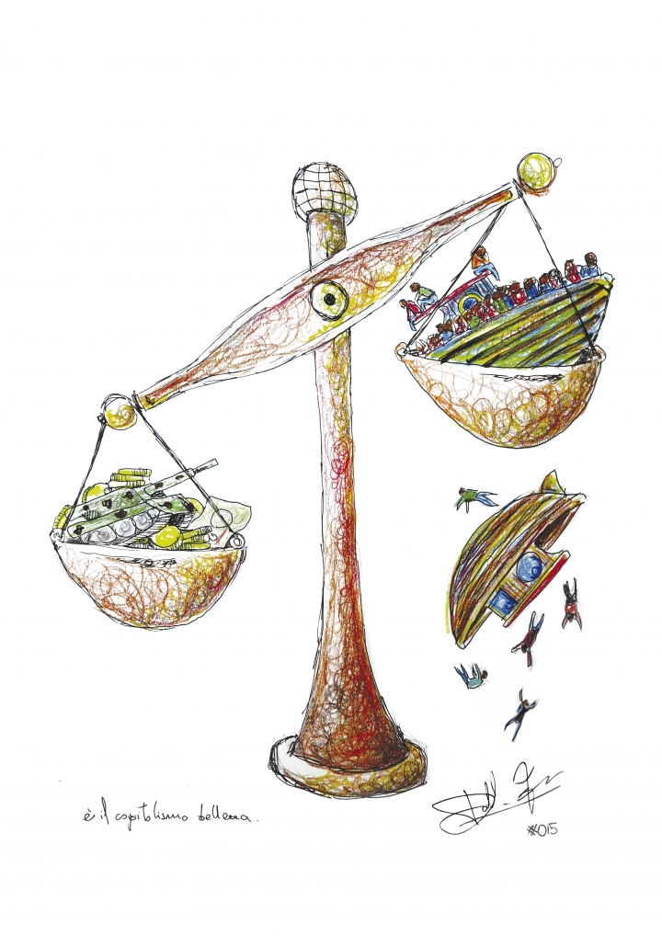
Paint artwork: Based on vectors by MalinaManiac.com
(Creative Commons Attribution 4.0)
Headline font: ED SZ (dafont.com/edo-sz.font)

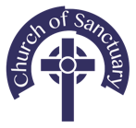

churchofsanctuary.org
ctbi.org.uk

